The first capsule hotel to conquer the world is located in Granada, Spain

- This capsule hotel (podtel) is called “DistrictHive” and is the first of several (Podtel Colony) to be placed in different parts of the world.

- It is a 100% self-sufficient autonomous module that represents a new way of understanding tourism from a sustainability and efficiency perspective.

- The podtel, luxuriously equipped and with room for up to four people, is controlled by Artificial Intelligence and is entirely managed through an App. It can be rented through its website, Booking and Airbnb

Madrid, september 2021. The tourism revolution has begun and is emerging from the heart of the Gorafe desert, in Granada (Spain). There, a state-of-the-art tourist project has just been launched aiming to change the current concept we have of luxury accommodation for travelers seeking the experience of total disconnection from the outside world, through deep immersion in the environment. The revolution is called DistrictHive® (www.districthive.com) and has arrived with the aim of expanding; because this capsule hotel (also called podtel®) is just the pilot project of many other locations that will conquer the most remote and beautiful corners of the planet.
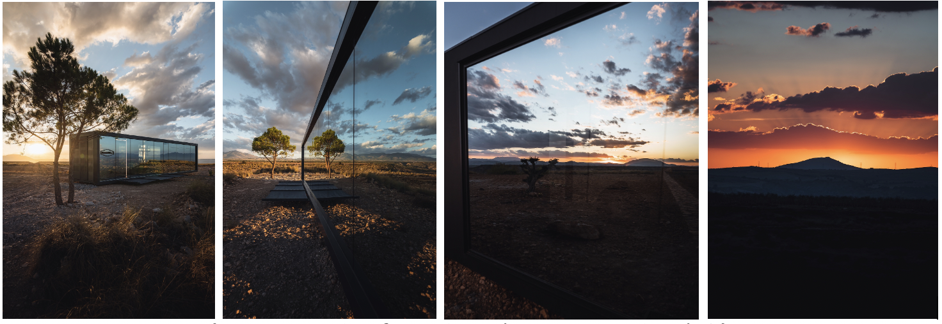
(DistrictHive Gorafe, en Granada, Spain. Fotos DistrictHive©)

DistrictHive is the first 100% self-sufficient and transportable module that can be deployed on any terrain, even where construction is not possible. This module, created by Portugal-based Districthive LDA company and an international team of architects, interior designers and engineers, has been designed from a multidisciplinary perspective and understands tourism in a sustainable, ecological and responsible way. It enhances the value of nature by accessing it without leaving a trace. The environmental impact on the area is zero since no local resources are consumed. Once removed, the location would remain in the same state in which it was previously found.

This eco-hotel is able to generate its own water from the air, its own electricity from solar energy, has enough energy to power it for 4 days without sun, has its own sewage management by transforming waste into ashes, and grey waters are filtered through two filtering processes so that the water serves as irrigation water. The complete autonomy of the module makes common and complementary services unnecessary, thus optimizing resources and ensuring a reduction in the carbon footprint.

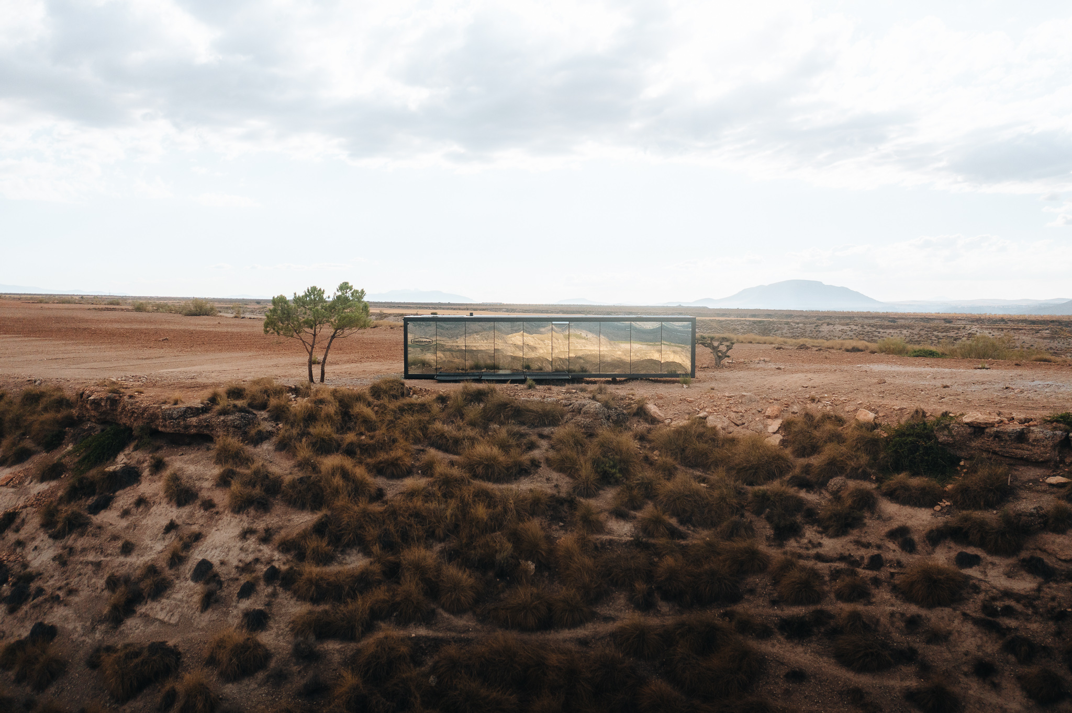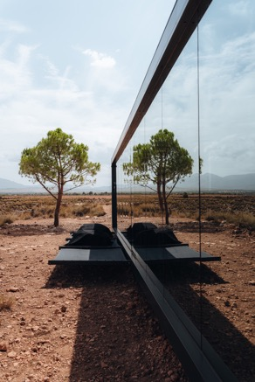
(DistrictHive Gorafe, en Granada, Spain. Fotos DistrictHive©)

A versatile construction with a focus on design
The podtel is a fully industrialized construction that is offered finished, transported to the site and in a few hours is ready to be used. It does not touch the ground on which it sits, has no foundations and does not require any type of channeling, piping or sanitation. The support system developed has 6 legs that, like a spaceship just landed on Mars, rest on the ground.

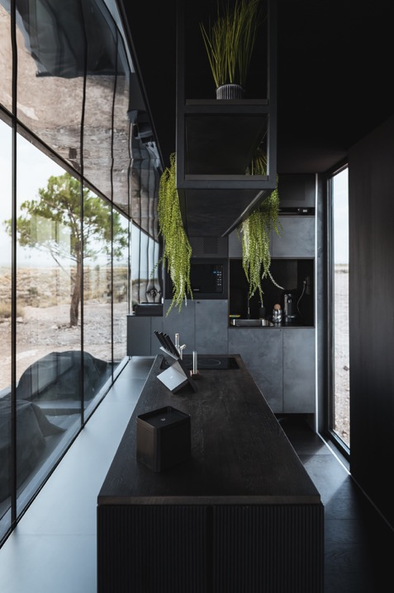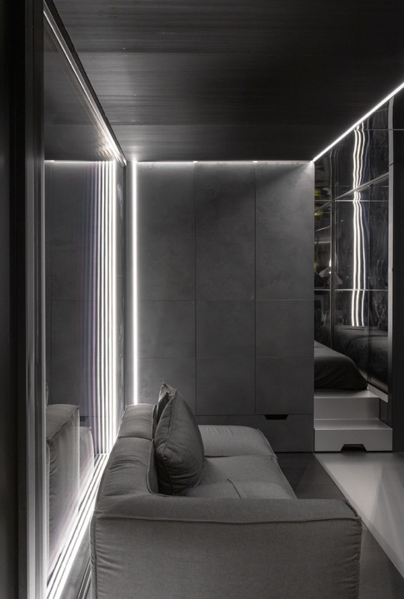
(DistrictHive Gorafe, en Granada, Spain. Fotos DistrictHive©)

The building is a small module of 35m2 divided into several spaces: a bathroom, a kitchen-living-dining room, a bedroom (one double bed and one hidden double bed), multifunctional modular cabinets and shelves, and a small and necessary installation room where all the technical equipment is concentrated. The podtel also has an open terrace for stargazing. In addition, all the furniture, storage spaces, walls and finishes, have been made with the utmost detail and care so that the final result was a design, intentionally pursuing an image of luxury and warmth.
The tourism of the future bets on Artificial Intelligence

Automation and the use of new technologies are essential for the development of the podtel. A mobile App controls all devices and provides information on remaining energy levels, solar production, temperature, water quality, water production... It also controls, among other things, the opening of doors, interior odour, lighting, sound, TV, the purchase of food and drink on demand, or the temperature. All from this App, called "DISTRICTHIVE": www.districthive.com/app.php

The capsule is controlled by an Artificial Intelligence, called "Hivemind". It has its own in-built system and motherboard that monitors all systems and energy consumption. It is intuitive and will assist guests throughout their stay to ensure a high-tech and connected experience, while they relax and enjoy the wonderful scenery in absolute privacy.

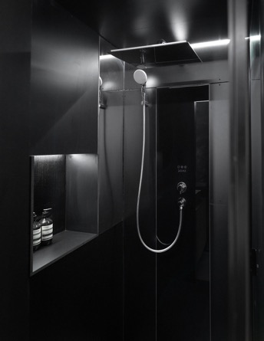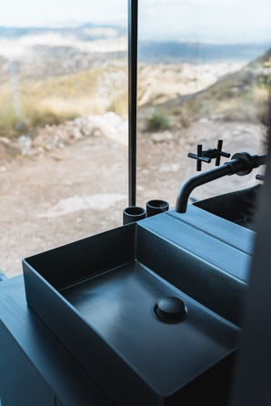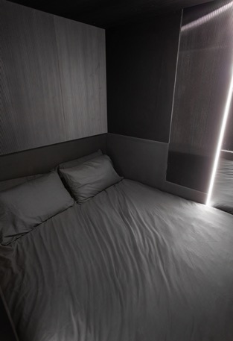
(DistrictHive Gorafe, en Granada, Spain. Fotos DistrictHive©)

DistrictHive is designed and conceived as the first of the so-called "Podtel Colony", a new and innovative concept of autonomous high-end luxury accommodation that will be scattered in different parts of the world, all of them remote and with the most spectacular views and environments.

Ultimately, it is an extremely exclusive model that seeks to showcase the value of the landscape, finding those wonderful and special places to make them accessible for protected contemplation throughout the year. The ultimate goal is to provide guests with a unique tourist experience for the enjoyment and delight of all the senses.

DistrictHive has made the podtels available for partnerships, international collaboration, investments and new site launches for both tourism and private sector use.

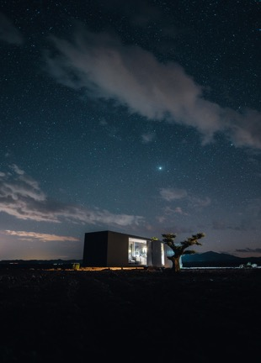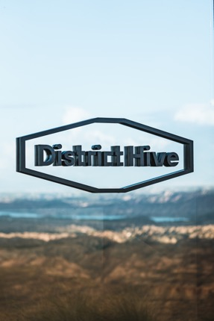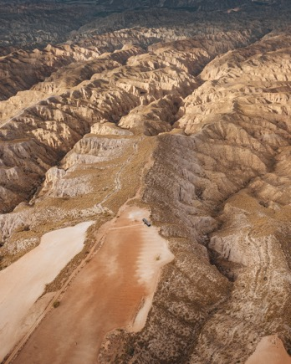
(DistrictHive Gorafe, en Granada, Spain. Fotos DistrictHive©)

Follow the project on Social Networks and don't miss anything!:
Instagram @districthive
Facebook @districthive
Twitter @districthive
Youtube @districthive

Live the DistrictHive experience!
Rentals at www.districthive.com, Booking and Airbnb.

DistrictHive (www.districthive.com) The world's first truly autonomous podtel (capsule hotel). The podtel is self-sufficient, environmentally friendly, energy independent and is fully activated through its App "DISTRICTHIVE", downloadable for Apple and Android. A concierge service is available 24/7 on the App to help guests with whatever they need. The App also has a neat information page for activities, restaurants and other recommendations. The podtel is fully equipped and has 35m2 of usable space, of which 30m2 are indoors. A sanctuary for travelers, social media fanatics, explorers and digital humans.

This capsule hotel is the first of the so-called Podtel Colony, a novel and innovative concept of high-end self-contained luxury accommodations that will be scattered in different parts of the world, all of them secluded and with the most spectacular views and surroundings. The goal is to provide guests with an unparalleled tourist experience for the enjoyment and delight of all the senses. Rentals at www.districthive.com, Booking and Airbnb.

DistrictHive information:
www.districthive.com
Phone number: +351 22 145 0770
Email: queenbee@districthive.com
Facebook @districthive | Instagram @districthive | Twitter @districthive | Youtube @districthive

Editorial and press contact:
CTC COMUNICACIÓN – www.ctccomunicacion.com -
Consuelo Torres / Beatriz Atienza / Paloma Betancort
Tlf (+34) 91 382 15 29
consuelo@ctccomunicacion.com
beatriz@ctccomunicacion.com
paloma@ctccomunicacion.com

